Battle pack Dordtse Krijgsheren

29 & 30 May 2025
Welcome to the Dordtse Krijgsheren Battle Pack!
We're excited to have you join us for this event. In this document, you'll find all the essential information to help you prepare.
This marks the third year of Dordtse Krijgsheren, and for the first time, we're expanding to a two-day event!
- Day 1: A competitive three-battle, 1995-point tournament.
- Day 2: A more relaxed day focused on casual play and open gaming.
Get ready for an unforgettable weekend of strategy, competition, and camaraderie!
This battle pack first describes the practicalities and then the in-game rules for day 1 and day 2.
—-----------
Practicalities:

Venue
The games will be hosted at the Energiehuis, a former power plant in Dordrecht.

Het Energiehuis
📍 Address: Noordendijk 148, 3311 RR Dordrecht

Parking
🚗 A parking garage is available directly in front of the venue.
🚶 A free parking lot, Parkeerterrein Weeskinderendijk, is a 10-minute walk away.

Contact
📧 Email: dortschekrijgsheren@gmail.com
Participants will get the phone numbers of the TO’s to get in contact with us. Additionally, we will make a whatsapp group for all participants for those willing.

Army List Submission
📱 Submit your list using the Mantic app with the provided tournament code: AFDO9Ia6qY
Please submit your armies for the first day before friday the 16th of may.

Costs
💰 Tournament Entry: €15
💰 Full Weekend (Both Days): €25

Payment Information
- IBAN: NL19ABNA0128605243 (T.H. den Boer)
- Please include your full name (or names if paying for multiple participants).

Food & Drinks
🍞🥤 A small bar will be available, run by our dedicated "fridge guardian"—show them some love!
🧀 Toasted sandwiches (tosties) and drinks will be available for a small fee.
Looking forward to seeing you there!
Opening hours of the location
Day 1: 09:00-22:00.
Day 2: 09:00-18:00
At day 1, the location may be closed formally (unclear yet), but we have a key. If this is the case, we’ll be at the door from 9:00 to 9:30. If you arrive after this time, please call us so we can let you in.
At day 2, the location must be empty by 18:00. Therefore we will stop the 2nd day by 17:00.

The story unfolds
"Your doctrine is a pillow for the flesh and the demons, a plane of the abyss from which they assail all men, wounds most, and strikes many fatally with the arrows of despair or complacency!"
With these words, Franciscus Gomarus concluded his argument before the entire synod. It was the final sentence in a tirade of condemnations against the Remonstrants, who, under the leadership of Jacobus Arminius, had sown unrest in the city. And not just in the city, but throughout the Netherlands. The synod, gathered in the Great Church of Dordrecht, was unanimous. Arminius was a heretic and should be condemned as such.
Jacobus Arminius locked eyes with the speaker, then turned to face the elders assembled in the great Gothic edifice.
"People of my blood. Do you not see the madness you bring upon yourselves by sowing discord in this devine house? The tree of knowledge of good and evil has entangled you in a web of division, judgment, and thus, damnation! Behold, the axe is already laid at the root of the tree. When you step outside, you will see a steel cannonball hanging from the wall where the Grote Kerksbuurt begins. A sign of the judgment that will befall this city! Repent while you still can, choose of your own free will the path of truth! The free will that you so openly reject!"
Arminius and his followers were violently cast out of the Temple and banished from the city. As he passed through the gates of Dordrecht, he shook the dust from his feet and sighed, knowing the judgment that awaited the city.
And the judgment came. A few days later, the frost set in. At first, it led to cheerful ice-skating on the Nieuwe Haven, but it soon became clear that this was no ordinary winter. The city's supply lines faltered under the harsh conditions, and hunger spread quickly. Farmers attempted to smuggle their sheep into the city by disguising them as people, selling them at extortionate prices. Those caught in the act were beaten with sticks, left to bleed out in the freezing cold.
It wasn’t long before the Oude Maas was completely frozen over, and the shifting ice put immense pressure on the city's fortifications. Several buildings along the Buiten Walevest collapsed, and the strain grew so great that the tower of the Great Church itself began to lean. The citizens prayed to any Gods willing to spare their city, but the heavens remained closed. The sun no longer shone, and snow began to fall. Not natural snow, but something sinister and malevolent. A storm unlike any had ever seen.
And the storm carried with it creatures that only the devout had ever read about in tales of damnation—wolves, Nightmares, ice spirits, and even demons prowled the frozen lands, encircling the city in a deadly dance. No one could enter, no one could leave. They were trapped like rats in a frozen cage.
The siege of Dordrecht, the oldest city in the Netherlands, had begun. And now, the fate of the city lies in your hands.Who will be the savior of Dordrecht? Or will the forces of darkness overwhelm it?
Welcome to Dordtse Krijgsheren 2025!

Day one, the battle for Dordt.
Will the city hold or be broken by the hordes swarming the ice?

Tournament Scenarios
The tournament consists of three battles:
- Push – Each player receives two loot counters instead of rolling.
- Hold the Line
- King of the Hill (Rules detailed below)

Time schedule
Every battle will be played in 2 hours and 15 minutes with 30+ minutes break in between.
Per battle each player has 60 minutes play time and 15 minutes to explain the armies, toilet breaks and discuss. Also mention to the enemy the position of your heroes for ascending the hill (not relevant in the first battle), more about this down below.

Time start | Duration | Time stop | Activity
09:00 | 0:30 | 09:30 | Door open
09:30 | 0:30 | 10:00 | Rule explanation and challenges
10:00 | 2:15 | 12:15 | Round one
12:15 | 0:45 | 13:00 | Ascending the hill and challenges and lunch
13:00 | 2:15 | 15:15 | Round 2
15:15 | 0:30 | 15:45 | Ascending the hill and challenges
15:45 | 2:15 | 18:00 | Round 3
18:00 | 0:30 | 18:30 | Ascending the hill
18:30 | 0:15 | 18:45 | The final score and winners

Opponent selection
Unlike standard tournament pairings, matchups will be determined as follows:

First Round:
- Players may issue challenges, but not against teammates.
- Any unchallenged players will be paired randomly.

Second & Third Rounds:
- The player with the lowest individual points selects an opponent of their choice. A random table is assigned via dice roll.
- The next lowest player (who has not been challenged) then selects an opponent, and so on.
- All challenges must be outside your own team.
- If the final players are from the same team, the tournament leader will randomly assign them an opponent.

Special Rules for Uneven Teams:
- If teams are uneven, the Organiser (Vincent & Theo den Boer) will act as Defenders of Dordt rather than joining a team.
- The Defenders of Dordt can be challenged, but they do not participate in the team competition.
We understand that players attend tournaments to face new opponents, not just their regular crew. This challenge system ensures variety and competitive matchups throughout the event.

Scoring System
The tournament uses two scoring systems:
- Individual score
- Tournament ladder

Individual Score
Players earn points based on the standard Mantic system:
- Win: 15 points
- Draw: 10 points
- Loss: 5 points
- Bonus Points: Up to 5 kill points and 5 objective points
The player with the highest individual score wins the tournament and is awarded the Key to the City.
Additional Victory Points are awarded based on the number of points killed from your opponent’s army:
Points Killed | Victory Points
0 - 275 | 0
276 - 675 | 1
676 - 1075 | 2
1076 - 1475 | 3
1476 - 1850 | 4
1851 - 1995 | 5

Tournament Ladder (The Mountain) - Team score
In addition to individual scores, players compete in a team-based game.

Team Selection & Rules
- Teams are randomly assigned and announced a few days before the tournament.
- Players only battle opponents from other teams.
- Each player brings three extra heroic miniatures to represent their team's ascent up the Mountain (Dordrecht Island). These miniatures can be anything (but please keep close to 20x20 or 25x25 due to space on the mountain) which should be clearly identifiable with your army.

Scoring & Advancement
- Each battle follows the standard scoring system (5–25 points).
- Winning a round? You may block one of the losing player's miniatures from moving up that round.
- For every 5 points earned, you can move one Hero up one level.
- Leftover points (e.g., you win 22 points, move up 4 levels, and have 2 points left) go into the team pool.
- After the third battle, the team decides how to distribute pooled points for the final ascension.

Strategic Decisions
- After each battle, teams privately submit their movement choices in a sealed envelope.
- 30 minutes between battles is allocated for:
  - Team discussions on Hero movement
  - Admin updates on individual scores
  - Challenge declarations for the next round
- Challenge Order:
  - The individual player score from lowest to highest determines the order in which players can issue challenges for the next round.

Winning the Team Game
- Victory is determined by the final positions of minis on the Mountain.
- Each level has a point value that is only scored if a team holds the majority on that level.
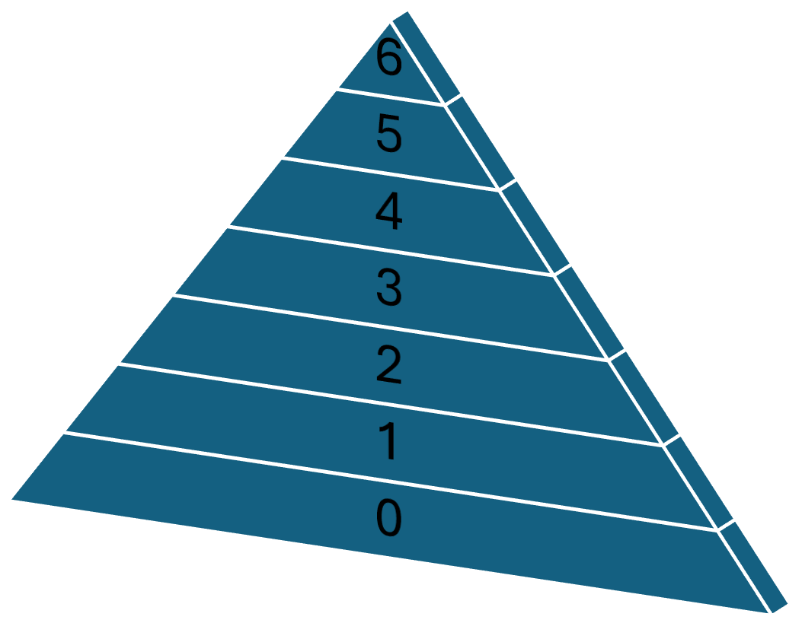
- 21 total points are available, but if a level is contested with no majority, its points are forfeited.

Example Outcome
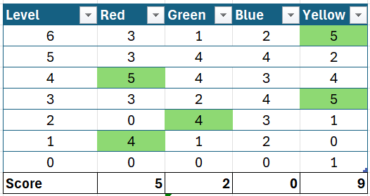
- Level 5 is contested (no majority) → No points awarded.
- Only 16 points remain in play.
- Team Yellow wins by securing Levels 6 and 3, totaling 9 points.

Tournament Clocks

Clock Usage
- Games will be played with a chess clock unless both players mutually agree to play without one. If you do not have a chess clock, there are free apps on your phone which work just fine.
- If playing without a clock, an admin will notify players 30 minutes before the round ends to ensure both have played an equal number of turns. However, it is the players' responsibility to track their time. The TO will determine the result of an unfinished game.

Clock Rules
- Chess clocks must run during:
  - Deployment
  - Scout moves
  - All player turns
- Clocks may be paused only for:
  - Roll-offs
  - Rules disputes
  - Toilet breaks
- Clocks cannot be paused for standard in-game checks (e.g., Line of Sight) unless there is a genuine rules disagreement requiring a rulebook reference or a Judge’s decision.

Clock Misuse & Disputes
- If a player suspects their opponent is pausing the clock unnecessarily or playing excessively off-clock, they should inform the TO immediately.

Player Timeouts
- If a player runs out of time, they must immediately stop rolling dice and take no further actions, including:
  - Nerve checks (any unresolved nerve checks result in a ‘Steady’ outcome).
  - Issuing orders or rolling dice for any reason (e.g., Regeneration, artefacts).
- The only exception: The Turn 7 roll may still be made.

Trophies & Awards

🏆 King of the Hill
- Awarded to the winner of the individual tournament.
- Rewards:
  - Key to the City
  - Everlasting fame
  - Custom 3D-printed miniature

🥈 Runner-Up
- Just missed their shot at glory!
- Reward: Custom 3D-printed miniature

🎨 Best Dressed Army (Best Painted)
- Players receive 3 stickers to vote for their favorite painted army and can distribute them as they want. This way, all participants (and even some crew) will be the judge.
- Reward: Custom 3D-printed miniature

🤝 The Diplomat (Most Sporting Player)
- Awarded to the most liked and sportsmanlike player of the event.

⚔️ Team Trophy
- The winning team is awarded the Rapier of the Mountain of Dordt.
- They also determine the city’s fate for next year’s tournament.

❄️ Frozen Solid
- For the player whose units got stuck the most (e.g., due to Nerve Tests or Disorder).

Rules & Guidelines

⚖️ Optional Rules
- The following optional rules will NOT be used:
  - Withdraw
  - Command Dice
  - Allies

🎨 Painted Armies
- Unpainteda and proxied models are allowed, but players are encouraged to bring fully painted armies. Please be considerate of your opponents and make it clear which of your units is which.
- A special prize is awarded for the best painted army.

🤝 Sporting Behavior
- Players are expected to compete in a fair, respectful, and enjoyable manner.
- The event promotes a fun and inclusive gaming experience for all.

🛏️ Accommodation
- Players traveling from afar can stay overnight—just contact the event organizers for details.

King of the Hill – Scenario Rules
The King of the Hill scenario is a slightly modified version of the 2020 “battle of the wolds” scenario posted in that year’s Clash of Kings book.

Rule Changes:
- This battle will be played with 1,995 point armies instead of the 1,000 points mentioned in the rule book.
- Instead of the normal three hills, there will be one large objective hill measuring approximately 25 cm².
- Victory Condition:
  - The player with the most Victory as shown below Points wins.
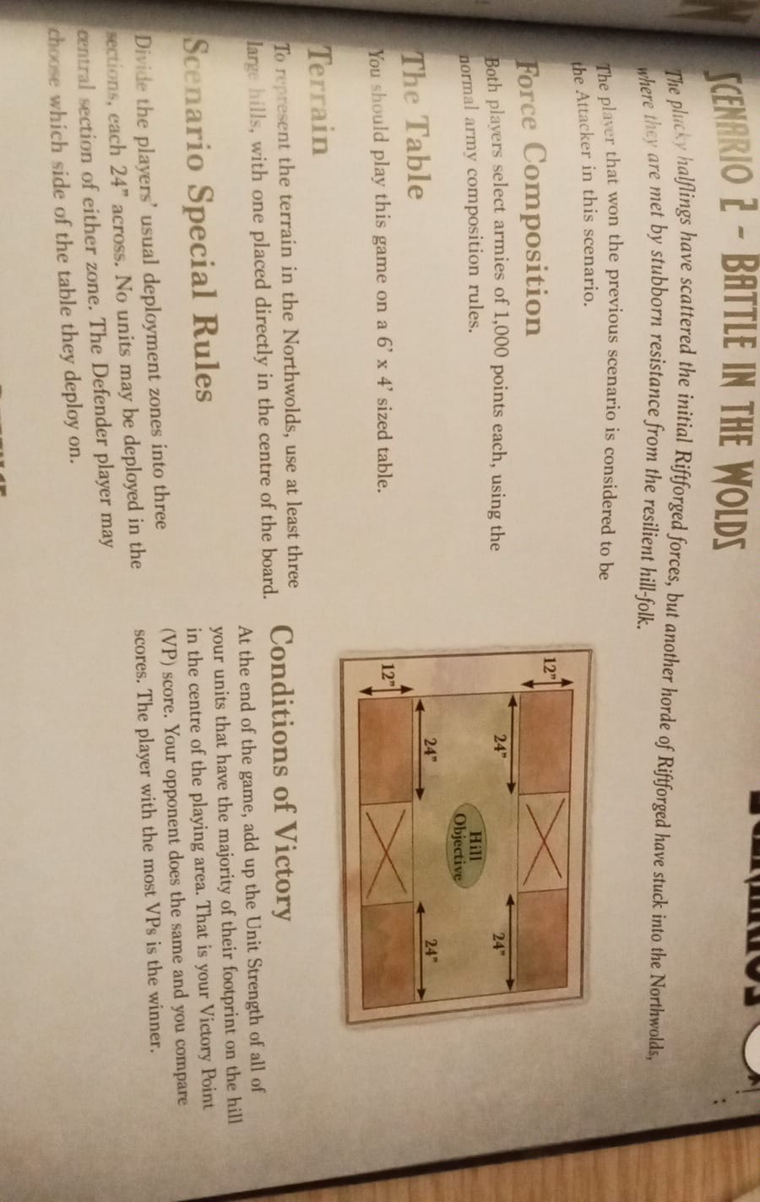
  - Scoring is capped at 5 Victory Points.

Day 2
Day 2 is going to be a casual laid-back day. While day 1 will be more competitive, day 2 should be about exploring new game systems and new opponents.

We will provide the venue and stimulate finding new opponents. Finally we’ll be providing a way of tracking your victories, for those willing to do so. The player with the most victories gets a small trophy.

Game types
To facilitate ease of finding opponents, we’ll be limiting formats and point allowances. Nothing sucks more than to arrive at a 2,300 points match with a 1,995 point army list. If you and your opponent agree on a different format/point allowance, feel free to do so! Day 2 is about freedom, so the formats below should be helping instead of limiting.

Feel free to contact people beforehand to agree on a match on day 2! We’ll be providing a poll in the whatsapp group to help you prepare.

Bring your army for one of the following formats:

- Kings of War Ambush, 750 points. Aiming for a quick and fast game? Bring your Ambush army and play a couple of games.
- Armada, 200 points. We have little experience in Armada, but would love to play. We’ll provide a table so we can explore this lovely game together!
  - As this is a starter game, please don’t use fliers or fortifications!
- Regular 1,995 points. Bring your tournament list or bring anything else. Roll for a scenario and start playing!
- Bodyguard 1,495 points. This is an experimental format as described at the end of this battle pack. Bring your 1,495 point army (including at least one individual character) and try to assassinate your opponent’s leader while protecting your own.

Time schedule

There is no set time schedule on day 2. As before, the location is open at 09:00 and we can play until 17:00. Please do help us clean up, so we can leave the location at 18:00 for the next user of the rooms.

Victory and scoring
Like at day one, please bring (at least) one extra heroic miniature.This miniature can be anything (but please keep close to 20x20 or 25x25 due to space on the mountain) which should be clearly identifiable with your army.

For each victory you earn this day, you can move your miniature up one level on the Mountain. If you earn more than five victories, you might need a 2nd miniature…..

Trophy: the winner of day 2
The leader of the casual board! (Most victories on day 2)
- Reward: 3D-printed miniature from the Mantic Vault

Bodyguard 1,495 scenario rules
Bodyguard is a variant scenario for Kings of War.
Your monarch arrives at the battle with a small retinue of loyal guards and finds his adversary doing likewise. Killing or capturing your rival will yield a whole lot of prestige!

Rules
- The game is played on a 4x4 table to prevent monarchs from fleeing too easily.
- Each player chooses a 1,495 point army with at least one individual character representing your monarch. if you choose to play with command dice, this individual gives one more red command die.
- Roll scenario as usual. (or pick one that you both like)
- Routing your opponent’s monarch yields 2 victory points.
- If the monarch survives and is on your opponent’s half of the board at the end of the game, you gain one victory point.
- Other victory points as per scenario.
- We recommend to play with all the optional rules.
Special rules for the monarch
- You don’t need unlocks for your monarch.
- The monarch may be any individual character from any army if it shares an alignment with your army,
- all special rules like inspiration, rally or aura’s count as if he is part of the main army ( if an aura says vicious for infantry, this means infantry for your main army as well)
You can add the monarch in your list as an ally. (making the list invalid due to unlocks)

